How do PC etc. clients access to the Internet?
For example: There are a router put in the first floor and a desktop put in the room of the second floor, if you want to access to the Internet without any complicated wiring.
The steps of setting:
❶ Please use cable to connect LAN port, and then plug the power adapter into the power socket.

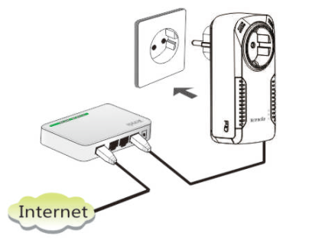
❷ Please use another cable to connect the LAN port of the powerline adapter, and then plug the power adapter into the power socket.
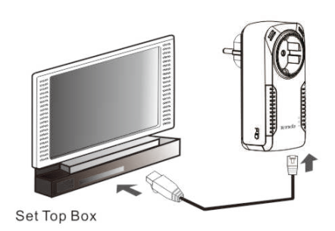
❸ Two powerline adapters will pair automatically after plugging into the power socket. It is successful to access to Internet when PLC light keeps on.
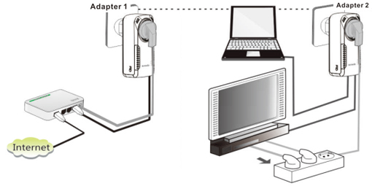

Note: In this circumstance, it is better to setup local area connection of desktop to obtain IP address and DNS server address automatically.

